
DECLARATION
I hold a copy of this assignment that I can produce if the original is lost or damaged. I hereby certify that no part of this assignment/product has been copied from any other student’s work or from any other source except where due acknowledgement is made in the assignment. No part of this assignment/product has been written/produced for me by another person except where such collaboration has been authorised by the subject lecturer/tutor concerned.

The Crisis Co-authorship Network: A Relational Data Visualisation Report

1. Introduction
The major focus of relational data visualisation is to highlight the relationship connection between individual entities, whereas conventional charts summarise the data attributes based on separate observations. The primary subject of analysis is created based on the structure of connections executed using relational visualisation. Network analysis is used to study the data and provides the most influential person in the group, how these groups are formed, the information flow, etc; all these analyses depend on the connection patterns of the group nodes rather than on any single individual (Afzal 2026).
Under relational data the entities (nodes) are described together as a group with the link (edges) between them. This is known as co-authorship network that particularly captures the collaboration structure, influential entity (node) and community formation within the given data for visual analysis. These networks tend to be valuable for historians and scientists who study the social organisation behind a body of work that an author list alone cannot explain it (Schaer, Myshkina & Keller 2023).
In this report the analyses are based on the co-authorship network contributors of The Crisis, a renowned magazine by National Association for the Advancement of Colored People (NAACP) founded by W. E. B. Du Bois. The objective of this study is to examine the collaboration patterns among the contributing entities using network visualisation, identifying the central authors and the overall shape of the collaboration. Three complementary visualisations network know as node-link, degree-centrality ranking and adjacency matrix are created and interpreted to understand the strengths and limitations of the approach.

2. Data Summary
The dataset covers the collaborative ties and contributors to The Crisis magazine. The network shows that each node is represented by an author, and the respective edge represents the co-authorship relationship between the two authors who appeared together on the same contribution. Collaboration frequency is recorded by the edge weight, indicating stronger and consistent relationship between the two nodes if the edges are heavier.
The implementation of network diagram was done using R language, on the two files node and edge list. The data was cleaned, removed self-loops and duplicate edges between the same authors were combined into a single weighted edge by combining the weights of the two edges, resulting in a non-directional and weighted graph with 96 authors connected by 273 unique collaboration edges. The lowest density of 0.060 was formed with an average path length of 5.94 and a diameter of 14, creating a global clustering coefficient of 0.191. Later the Louvain algorithm was applied to identify communities, proximity and the most influential authors based on their position.

3. Technical Description of the Visualisation

Network graph
The network visualisation (Figure 1) was created using the node-link diagram, where the authors are drawn as points and collaborations as connecting lines, with a force-directed layout that treats edges as elastic links and nodes behaving as repulsive entities, repeating until the system settles down to a low-energy arrangement (Zhang, Xu & Quan 2023).
The visual clearly represents high collaborative authors in a large circle, created by mapping node size to degree with colours representing the Louvain community. Text labels highlighting important authors with a degree of fifteen or more are used to avoid clusters.
The use of force-directed layout helps to combine strongly connected authors while weakly connected once drift apart, resulting in a spatial cluster with highly connected nodes at the centre creating clear visual of the network structure without any manual intervention (Zhang, Xu & Quan 2023).

Degree centrality
The direct collaborators of an author are measured using degree centrality, where a large degree represents more collaboration and reasonably the most influential author within the network contributors of the magazine. The metrics of degree and related centrality is considered as the most effective ways to interpret the most influential author from the network data (Afzal 2026). Degree is represented through node size in Figure 1 and author ranking in Figure 2, where the size of nodes is captured in the figure 1 and their ranking is shown in figure 2.

Louvain community detection
The Louvain algorithm is used for segregating the network into groups based on maximum score which is highest among the edges inside the group and few between them. The algorithm detects the most collaborative authors among the group of networks and creates a community that corresponds to a clearly defined cluster of editors. Louvain is widely considered for providing strong performance in identifying community structure on real-world networks (Kumar & Singh 2024). Four communities of 40, 27, 18 and 11 authors respectively are produced using the algorithm.

Software
The entire visual analysis in this report is created using R. All the graphs were examined using the igraph package a library with beginner-friendly interface used for community-detection and layout algorithms (Antonov et al. 2023); along with ggraph and ggplot2 for creating the static network and bar chart; and visNetwork for interactive version, which adds the zooming, hovering, and community filtering feature.

Adjacency matrix
In figure 3 weighted adjacency matrix both the axes are occupied by the authors and cell (i,j) are shaded by collaboration weight. A symmetric matrix is created by an undirected graph, whereas the removal of self-loops created blank diagonal. For visibility purpose, only 25 highest-degree authors are shown, arranged in Louvain community and degree; the ordering is the choice of design and not data.

4. Analysis of Figure 1: Network Visualisation
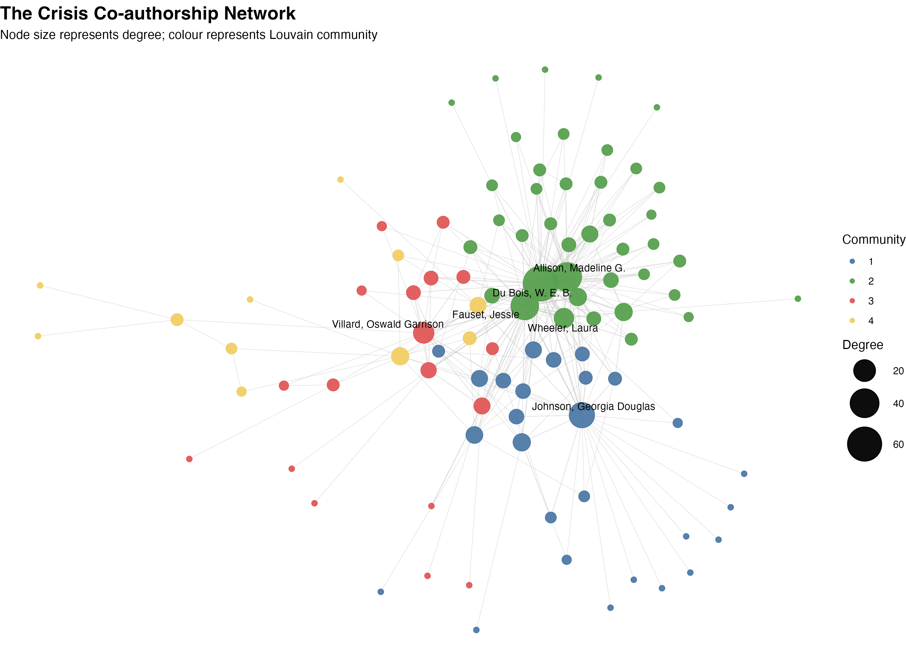
Figure 1. The Crisis co-authorship network.

Overall structure
The network has low edge density roughly around 0.06, refereeing to 6% of all the possible collaborations that occur. Regardless, the layout reveals a clear and compact core with scattered peripheral authors. The graph clearly represents a small number of highly connected nodes at the centre of the cluster, while may contributors at the outer edge connected with a single tie.

Communities
The four communities are created using the Louvain algorithm with a modularity of 0.264. These communities are bifurcated by different colours. The largest community with 40 authors dominated by Du Bois is represented in green. The upper-left position of the diagram is occupied by the community in blue anchored by Georgia Douglas Johnson. The yellow community positioned at the bottom-left of the diagram and the community in red representing the lowest collaboration group positioned at the bottom of the diagram.

Important authors
Only few authors dominated the network structure with Du Bois as the founder and editor of the hub representing the largest node, with a degree of 63, connecting with a huge share of contributors. The second largest node with a degree of 40 is represented by Allison, Madeline G. highlighting the strong influence within the green community. The node between the green core and other clusters is represented by Fauset, Jessie, with a degree of 36. The largest node in blue community is represented by Johnson, Georgia Douglas, at degree 29. The degree itself does not tell the whole story of connectivity as the betweenness centrality identifies Georgia Douglas Johnson (0.218) and Villard (0.136) as a strong bridge between communities. This clearly indicates the authors are holding separate clusters together even when they are not the largest collaborators.

Peripheral authors
The majority of the nodes are small with only one or two collaborations. Most of them are positioned outside the diagram and highlight an imbalance in collaboration among few nodes, while most authors participated only briefly or through a single tie.

5. Analysis of Figure 2: Top 15 Authors by Degree Centrality
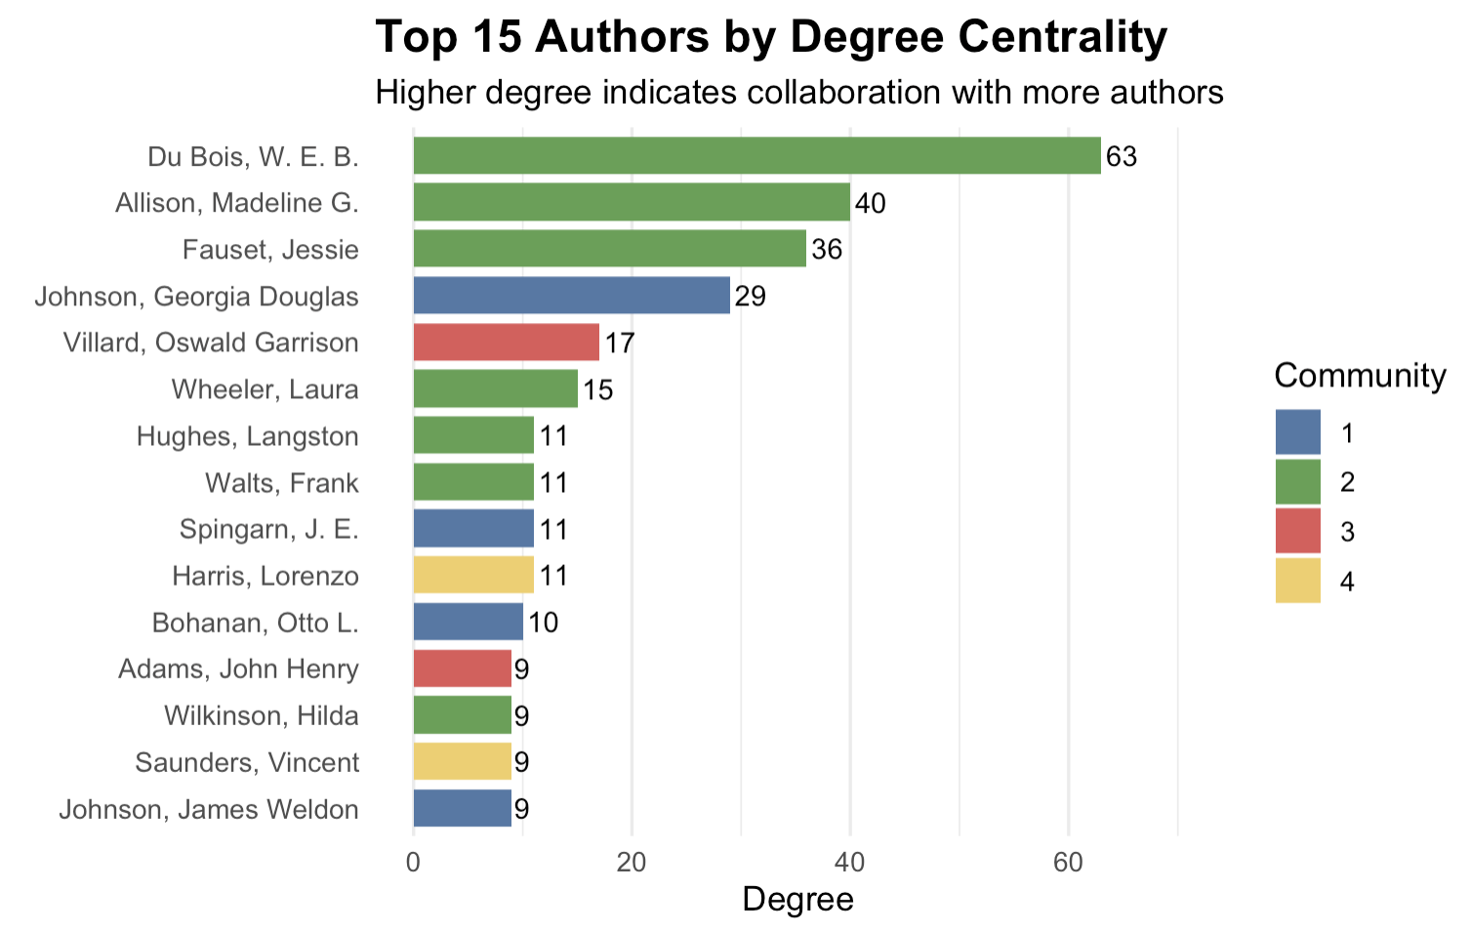
Figure 2. The fifteen authors with the highest degree centrality, coloured by Louvain community.

Figure 2 shows the top fifteen authors with the highest degree in the network was interpreted using the degree centrality method. The more co-authors are involved an increased central and potentially influence the contributor (Afzal 2026). The above figure 2 shows the top fifteen highest-degree authors in the network structure.
Du Bois the highest dominant network with a degree of 63. The gap between the first and the second is of 23, with Allison at 40 standing on the second place and Fauset at 36 and Johnson at 29 at third and fourth place respectively. After Wheeler at 15, there decline in the degree with most of the authors clustering around degree 9 and 11. The collaboration of the magazine revolved around a handful of central figures rather than distributed equally between active contributors.
The communities are represented using the bar colour. Community green dominates the chart by supplying to the top three ranking authors and several others in the list, clearly indicating the that huge number of the network influential authors are part of the same collaboration group, concentrating not only connections but also community membership around the editorial core.

6. Analysis of Figure 3: Adjacency Matrix
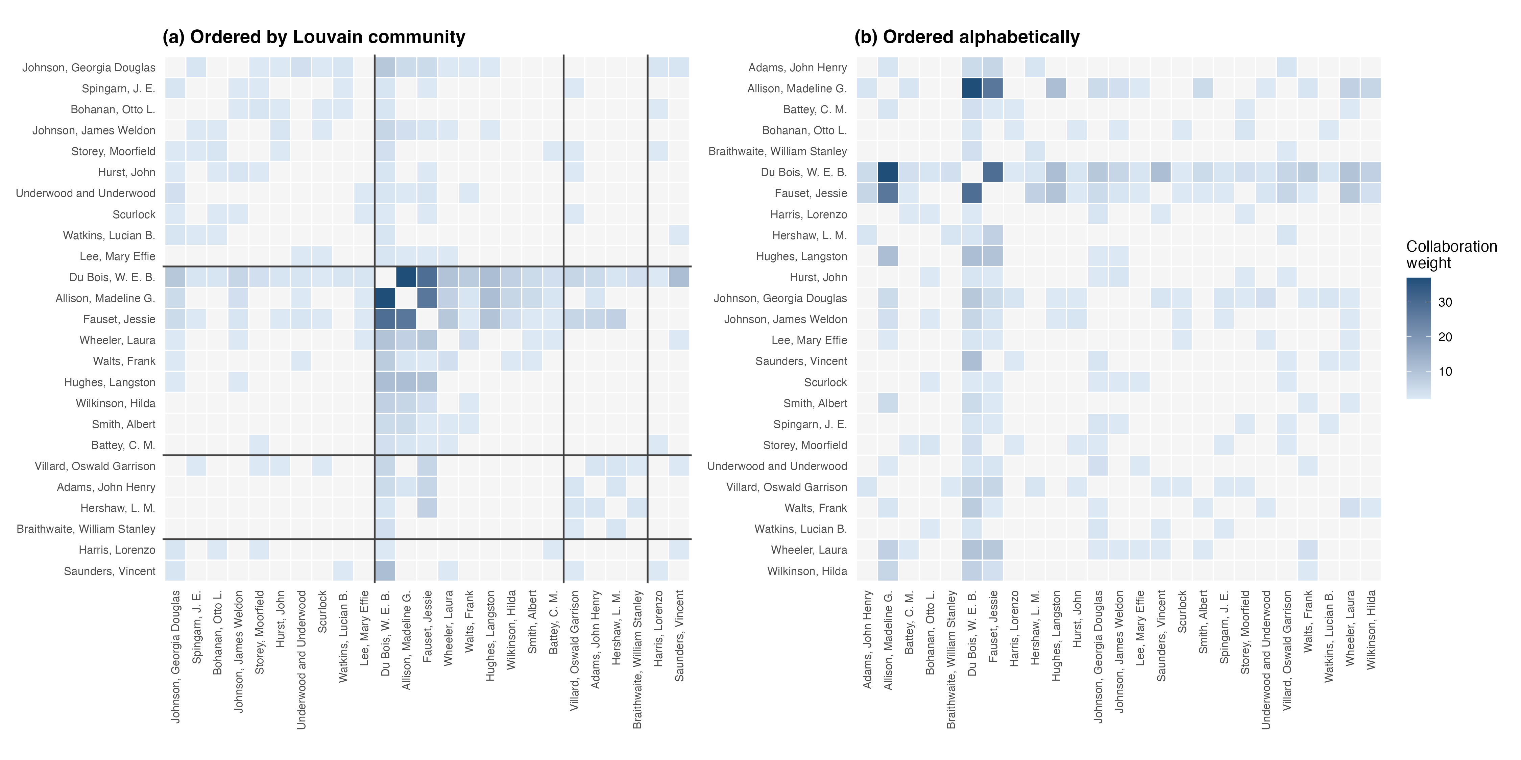
Figure 3. Figure 3. Adjacency matrix of the top 25 contributors:
(a) Arranged using Louvain community and degree.
(b) Arranged alphabetically by cell shading representing collaboration of weights.
The four Louvain community in figure 3(a) is represented by dark diagonal blocks, indicating strong collaboration within the group. However, when arranging the same data alphabetically, the block structure disappears as shown in figure 3(b). Weak separation and cross-community collaboration is identified when there is off-diagonal shading with a modularity of 0.264. For example: The network wide connection is demonstrated for DU Bois is dark row and column extended across all communities.

7. Scalability
The adjacency matrix is represented by n² cells, where 96 authors cover 9216 cells in the matrix. The 546 symmetric off-diagonal cells are occupied by 273 undirected edges, with a consistent network density of 0.0599. The matrix is useful for analysing dense network and not extensive sparse network, whereas node-link diagram performs better for analysing sparse network but clustered when the density increases. However, the force-directed diagram can handle 96 nodes, the calculation still requires O(n²) operations, and the changes can be implemented by O(n log n) using Barnes–Hut approximation.

8. Comparison of Visualisation Methods
The individual collaboration is readable by eliminating the edges crossing in the adjacency matrix, resolving the intercepting edges in figure 1. The main problem is to identify the paths and bridging position, for example: With a degree of 29, Georgia Douglas Johnson has a 0.218 betweenness centrality, but the bridging is clearly readable in figure 1 when compared with the matrix. Therefore, topology and paths are shown by node-link diagram and collaboration strength with adjacency is shown in the matrix.

9. Literature Review
The recent study supports the node-link method used for analysis, emphasising the degree and the related centrality metrics are the most effective way of capturing network influencer, indicating as the primary indicator of authors importance (Afzal 2026). Co-authorship network in scientometric analysis is used for identifying the most connecting link among the authors (Schaer, Myshkina and Keller 2023). The Louvain algorithm was identified to perform consistently in the use to identify the community structure (Kumar and Singh 2024). The node-link diagram was directed by a survey of large-graph layout enhancement (Zhang, Xu and Quan 2023). At end the igraph library was documented to capture the entire visual analysis together (Antonov et al. 2023).

10. Critical Discussion
The visualisation clearly exhibits the central node of the network structure, along with its community and collaboration with its peripheral contributors. With multiple changes the analysis could be deepen. The changes in weighted degree which counts the collaboration frequency instead of counting distinct partners, might better indicate true collaborative intensity. With this slight change the rankings can be sharpened rather than overturning it; Du Bois extending to a weighted average of 287 against Allison’s 181 and Fauset’s 165. The betweenness is accurately identified among bridge authors: Georgia Douglas Johnson (0.218) and Villard (0.136) score is particularly related to their degree (Schaer, Myshkina and Keller 2023). Splitting the data by year using temporal analysis would highlight the collaboration evolved as editors. Further work could capture the changes over time with detailed network citation.

11. Conclusion
The report successfully highlights the influential authors, collaborators, community hubs among The Crisis data using the network visualisation methods by creating node-link diagram, degree-centrality ranking, and adjacency matrix for understanding the overall structure and community layout. The bar chat confirms the author dominance by Du Bois ranking the most influential author. Further using temporal analysis, we can trace how the magazine’s collaborative community is formed and track the changes.

References
Afzal, MT 2026, ‘Socionetwork-based evaluation of academic systems: integrating centrality metrics into empirical ranking frameworks’, The Review of Socionetwork Strategies, vol. 20, no. 1, pp. 53–90.
Antonov, M, Csárdi, G, Horvát, S, Müller, K, Nepusz, T, Noom, D, Salmon, M, Traag, V, Foucault Welles, B & Zanini, F 2023, ‘igraph enables fast and robust network analysis across programming languages’, arXiv, viewed 24 July 2026, https://arxiv.org/abs/2311.10260.
Kumar, P & Singh, D 2024, ‘The evaluation of community detection techniques on real-world networks’, Social Network Analysis and Mining, vol. 14, no. 1, article 162.
Schaer, P, Myshkina, S & Keller, J 2023, ‘Preliminary results of a scientometric analysis of the German Information Retrieval community 2020–2023’, arXiv, viewed 24 July 2026, https://arxiv.org/abs/2310.07346.
Zhang, S, Xu, R & Quan, Y 2023, ‘Large graph layout optimization based on vision and computational efficiency: a survey’, Visual Intelligence, vol. 1, article 14.

